 **ANNA UNIVERSITY** 

**NAAN MUDHALVAN – GUIDED PROJECT**

**EMPATHY MAP**

**FARMER INSURANCE CHAIN**

|  |  |
| --- | --- |
| DATE | 31 OCTOBER 2023 |
| TEAM MEMBERS WITH NM ID | 1. ASWIN KRISHNA M –   93A42A8D371667AB4A04EAAC81B6B402   1. BHARATHI R - EA3E07A3A89131DA782474D19C6F8249 2. BOOPATHI J- FEBCCCA7D2B925CB9D24C6BDAF4CB1AE 3. DEEPAK K - 8F31A2F3B69C15BB1AA4A19BACAD94F6 4. VINOTH P- 3B7F07DDBB06A4ABF8B47C6AAB51207F |
| PROJECT NAME | FARMER INSURANCE CHAIN |
| COLLEGE NAME | ALAGAPPA COLLEGE OF TECHNOLOGY, ANNA UNIVERSITY |

**Empathy Map Canvas:**

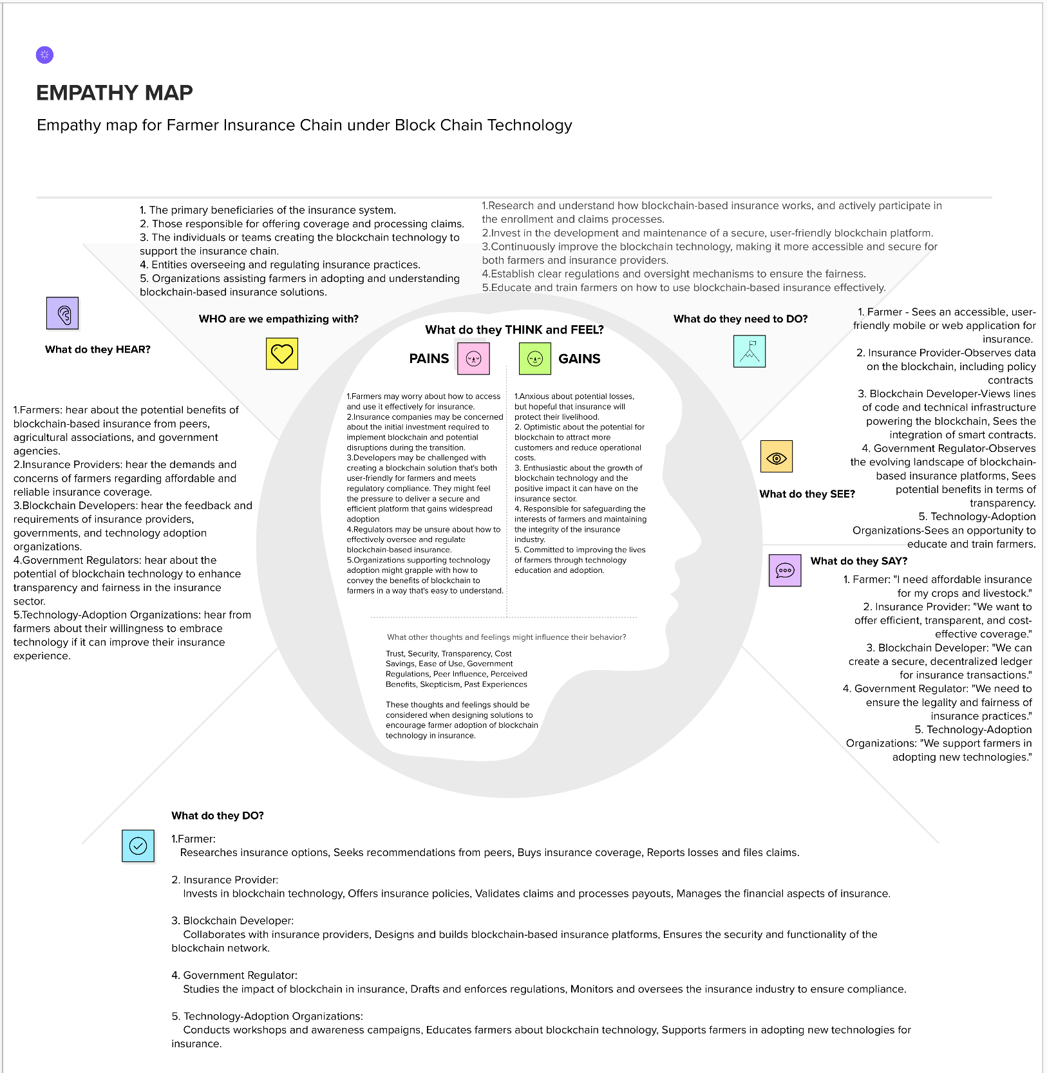

Empathy map file (Mural website):

<https://app.mural.co/t/aswinkrishna7155/m/aswinkrishna7155/1698685497223/493e2fd91e1279524e9794ab7e19bd1ec34f8504?sender=uff929a593e4515a1f1f17577>